Scope of Work

PROJECT TITLE: Development of a Hyper Local Air Quality Monitoring Network
for Cheverly-Capitol Heights

- Purpose
Seeking to address concerns over air pollution related to local industrial activities and traffic, Dr. Sacoby Wilson and team with the Community Engagement, Environmental Justice, and Health (CEEJH) Laboratory at the University of Maryland School of Public Health will work with the towns of Cheverly and Capitol Heights, Maryland to develop a hyper local air pollution monitoring network. The network will use low-cost real-time sensors to provide baseline air quality data that can be used for understanding pollution levels near sources of concern, educate local residents, inform decision-making about future industrial expansion, and help with mitigation efforts.

We will prioritize monitoring near the following stationary sources: 1) the World Recycling Co. E-waste recycling facility in Cheverly (38.917306, -76.911286), the Smith and Sons Scrap Metal Recycling facility in Capitol Heights (38.915069, -76.931704), and the LaFarge North America concrete batch plant in Capitol Heights (38.906880, -76.905092). In addition to these stationary sources of pollution, their associated mobile sources of pollution (including fossil fuel burning vehicles such as trucks, heavy equipment and locomotives), and pollution related to commuter traffic will also be investigated as these represent a high concern for residents in nearby neighborhoods.

- BACKGROUND ON POLLUTION SOURCES.
Metal and E-waste Recycling Facilities. Metal or scrap recycling creates several concerns for environmental and occupational health. In China, researchers have linked e-waste (scrap electronics) open-air burning to levels of cadmium, copper, lead, and zinc in soil and crops; levels that exceeded government regulations for food (Luo et al. 2010). Smelting and burning of Automotive Shredder Residue (ASR), plastic or other non-metal components of scrapped vehicles, can also produce incredibly toxic persistent organic pollutants (POPs) such as polychlorinated biphenyls (PCBs), dibenzo-p-dioxins (PCDDs), and dibenzofurans (PCDFs) (Buekens & Zhou, 2014; Nie et al. 2012; Tysklind et al. 1989). Direct emissions aside, vehicles used for loading and unloading scrap metal are another source of air pollution. Given the building materials of many modern electronics that are scrapped, workers in the scrap industry have increased risk of exposure to toxic metals including cadmium and mercury.

Concrete Block Facilities. Industries which manufacture and utilize cement release about 5% of global carbon emissions (most notably CO₂) and consume high amounts of energy (Huntzinger & Eatmon, 2009). The production of concrete involves the mixing of cement with fine aggregate (e.g. sand), coarse aggregate (e.g., gravel, crushed stone, or iron blast furnace slag), water and, in some cases, small amounts of chemicals known as admixtures or pozzolan minerals (e.g., fly ash, silica fume) (Office of Air Quality Planning and Standards, Office of Air and Radiation, & US EPA, 2006). Chemical dust (a visible pollutant of cement and pozzolans) is released in considerable amounts by concrete production. Cement or concrete plant emissions can be classified as fugitive (not released via a vent or stack, e.g. dust from stockpiles, materials handling, and PM from vehicular movements) or point source emissions (released through a single point source, via a vent or stack, into the atmosphere) (Gupta, Majumdar, Trivedi, & Bhanarkar, 2012).

Potential sources of PM and VOC emissions from concrete plants include raw material handling, storage, bulk loading and packaging of final product. Also, particulates released from cement industry fall within 0.05 to 5.0 microns in diameter, while, plants without dust control technology emit particles less than 10 and 2.5 microns (Gupta et al., 2012; Schuhmacher, Domingo, & Garreta, 2004). Currently, there is limited information on the emission of PM_{2.5} and VOCs from cement and concrete batching plants; however, crystalline silica, lime, gypsum, nickel, cobalt and chromium compounds, all of which are detrimental to human health, are found in cement (Gupta et al., 2012). Research has shown linkages between exposure to cement dust and adverse effects on human health. Construction workers exposed to inorganic dust (e.g., asbestos, man-made material fibers, cement, concrete and quartz) had increased chronic obstructive pulmonary disease (COPD) mortality (Bergdahl et al., 2004). Also, concrete and cement workers had a higher risk of COPD and nonspecific lung disease because of exposure to inorganic dust (Heederik, Kromhout, Burema, Biersteker, & Kromhout, 1990; Hnizdo, Sullivan, Bang, & Wagner, 2002). Blue-collar workers (e.g., contractors, plumbers, construction and cement workers) exposed to inorganic dust have increased risks of developing IgG4-related diseases (i.e., autoimmune pancreatitis) (de Buy Wenniger, Culver, & Beuers, 2014). One study found an increased risk in hospitalizations for cardiovascular or respiratory illnesses due to exposure from cement plant emissions, with children being more susceptible (Bertoldi et al., 2012). Residing near a cement plant leads to an increased risk of mucous membrane of the eye and respiratory system from exposure to emissions (including particulate matter) (Mehraj, Bhat, & Balkhi, 2013; Nkhama, Ndhlovu, Dvonch, Siziya, & Voyi, 2015).

Traffic-Related Air Pollution (TRAP). PM emissions from road transport are classified based on the method of formation. It is assumed generally that the principal method of PM formation is via combustion of fuels (gasoline and diesel) through internal combustion engines which release emission via the vehicle’s tailpipe (Alvarez-Vázquez, García-Chan, Martínez, & Vázquez-Méndez, 2017; Kim, Kabir, & Kabir, 2015; Mustafic et al., 2012; US EPA, 2015). However, total road transport emissions encompass the relationships between vehicles, road surfaces and the use of brakes. These interactions generate PM in the form of non-exhaust emissions. Non-exhaust emissions result from tire wear, brake wear, road surface wear (occurs via mechanical abrasion, grinding, crushing and corrosion processes) and resuspension of the dust on road surfaces (Mustafic et al., 2012; US EPA, 2015). Exhaust emissions contribute fine particulate matter (PM_{2.5} less than 2.5 microns in size) while non-exhaust emissions contribute coarse particulate (PM_{2.5-10}; ranging in size from 2.5-10 microns) into the atmosphere (Alvarez-Vázquez et al., 2017; Mustafic et al., 2012).

As an important source of air pollutants, vehicular emissions have been associated with particulates, carbon monoxide (CO), sulfur oxides (SO_{x}), nitrogen oxides (NO_{x}), heavy metals, particulate matter (PM), volatile organic compounds (VOCs), and polyaromatic hydrocarbons (PAHs) (US EPA, 2015). These air pollutants can lead to a wide range of adverse health effects including acute and chronic cough, bronchitis, asthma, reduced lung function, lung cancer, cardiovascular disease, decreased cognitive function, emergency visits and increase in hospitalizations in children, and increased mortality risk after hospitalization with acute heart failure (Afroz, Hassan, & Ibrahim, 2003; Arias-Ortiz, Icaza-Noguera, & Ruiz-Rudolph, 2017; Fernández-Navarro, García-Pérez, Ramis, Boldo, & López-Abente, 2017; Mecklenburg County, North Carolina, 2014; NJDEP, 2018; TCEQ, 2018; US EPA, 2016). Maternal exposure to TRAP can increase the risk of preeclampsia and preterm birth. Exposure to PM can lead to premature death in people with lung or heart disease, increase in stroke attack, increases in blood pressure, central nervous system diseases such as Alzheimer’s, decreased life expectancy and cancer (Colvile, Hutchinson, Mindell, & Warren, 2001; Hirsch et al., 1999; O’Connor et al., 2008; Shah et al., 2013; Wjst et al., 1993).

- TARGET-AREA PROFILE. The environmental and demographic results from an Environmental Protection Agency (US EPA) EJScreen review of the Cheverly-Capitol Heights area reveal the following. Cheverly was ranked in the 35th percentile for particulate matter, 84th percentile for diesel particulate matter and 85th percentile for air toxic cancer risk (Table 1). Additionally, 75% of the population includes people of color, 25% of the population are listed as low-income, and 14% of the population have less than a high school education. Capitol Heights was ranked in the 32nd percentile for particulate matter, 72nd percentile for diesel particulate matter and 59th percentile for air toxic cancer risk (Table 5) with 99% of the population composed of people of color, 23% of the population listed as low-income and 18% of the population having less than a high school education.

- GOALS OF THE AGREEMENT. The UMD team will collaborate with the towns of Cheverly and Capitol Heights to build a hyper local air quality monitoring network near industrial sources of concern and spaces of common, public value (including schools, community centers, libraries, parks, and churches and other places of worship). These locations will serve as stationary monitoring sites.

This network will utilize two types of air quality sensors: 1) the Purple Air PA-II and 2) the Aeroqual AQY1. These sensors monitor the air quality 24 hours per day with adjustable settings to measure data at 1, 5, 10, 15, 20, and 30 minute intervals; or 1, 2, 4, 8, 12, and 24 hour intervals. Purple Air sensors are real-time, fixed sensors which utilize dual laser beam technology to detect particulate matter (PM₁₀, PM_{2.5,} and PM₁) particles by their reflectivity, calculating particle weights from these counts. Aeroqual AQY1 sensors are small and cost-effective fixed sensors which monitor particulate matter, ozone, and nitrogen dioxide in addition to temperature, humidity, and dewpoint. Like the PA-II sensors, the AQY1 uses laser-scattering technology to detect particulates but only in the PM_{2.5} size range. The benefit of these units over the PA-II is the capability to store thousands of data points on the 16GB SDHC memory card in case of a cellular network outage. The sensors will be installed in shaded areas, away from direct sunlight and away from vents and other sources of pollution. These sensors will be attached to the exterior walls of houses and buildings in affected neighborhoods with each sensor placed eight to ten feet off of the ground. Data collected by these sensors is transmitted to a cloud database where it can be stored and downloaded via the sensor manufacturer’s website. Each sensor will be connected to a power source (most likely the building’s electrical power) and Wi-Fi (via dedicated cellular mobile hotspots or building’s internet).

- OBJECTIVES AND DELIVERABLES
Objective 1: Collaborate with community leaders to develop an Air Quality Monitoring Plan. The research team will work with the Mayor of Cheverly as well as local community leaders and residents to determine specific air monitoring locations for the sensors. Primary monitoring will occur near the following pollution sources: World Recycling Co. E-waste Recycling Facility, the Smith and Sons Scrap Metal Recycling Facility, and LaFarge North America Concrete Block Plant. Additional locations should include areas of high community significance at human receptor sites near the stationary pollution sources and heavily trafficked roadways (such as schools, parks, homes, churches, libraries). To determine spatial gradient of air quality, sensors will be located close and far away from the sources of pollution. We will meet with the Mayor to obtain feedback on the locations for the sensors.

Deliverable(s). Partners will develop selection criteria based on community priorities and utilize the EPA’s EJScreen tool to select sensor locations. Partners will produce both a map for visualizing these sites as well as a summarized list of locations and rationale for selecting them. See following map for possible locations of stationary monitors in communities of concern.

Outcome start date: February 1, 2019
Outcome end date: February 28, 2019
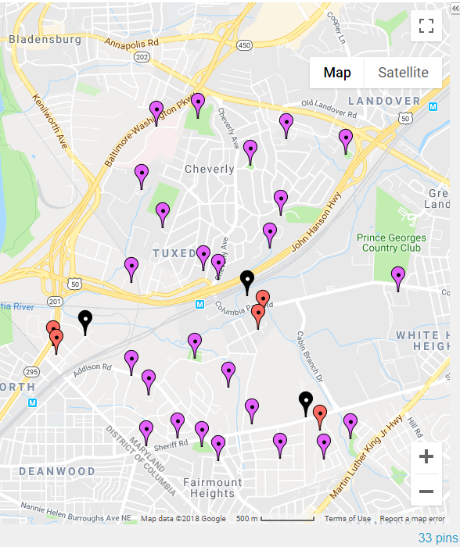
Figure 1. Sensor Locations (n=30) for Cheverly-Bladensburg Air Quality Monitoring Network. This map indicates stationary sources of concern (black pins, n=3), Aeroqual AQY1 fixed sensors collocated with Purple Air mobile sensors (red pins, n=5), and ancillary Purple Air mobile sensors for local and hyperlocal air quality monitoring (purple pins, n=25). See Table 6 for complete list of proposed monitoring locations.

Objective 2: Sensor Deployment. Utilizing the Air Monitoring Plan established under Objective 1, members of the research team will install sensors in two phases. Prospectively, the major elements of the monitoring plan will be fenceline and neighborhood monitoring. Fenceline monitoring captures emissions near the periphery of industrial facilities. Fenceline monitoring will be conducted near the Joseph Smith and Sons and the World Recycling Center in Cheverly and near the concrete batch plant on Sheriff Road. While, neighborhood monitoring will occur at points farther away from facilities such as intersections with industrial and commuter traffic and points of interest where residents can be exposed to air pollution. This monitoring will help us assess the spatial gradient of air pollutants of concern.

Phase I - Deploy Aeroqual Sensors. We will install five Aeroqual sensors at the fenceline of the industrial sources of concern. Smith & Sons Metal Recycling and World Recycling Co. will have two sensors each. While, one sensor will be installed near the Lafarge North America concrete batch plant.

Phase II - Deploy Purple Air Sensors. Also, five Purple Air sensors will be installed at the fence-line of each facility and will be collocated with the Aeroqual sensors. Twenty-one Purple Air sensors will be placed at human receptor locations which will be identified and will be agreed on with the Mayor and other stakeholders. Residential monitoring will take place at schools, libraries, parks, town halls, churches, and other identified locations (see map and locations below).

Deliverable(s): Research team will install five (5) Aeroqual AQY1 sensors and twenty-four (25) Purple Air PA-II sensors at locations agreed upon in the Air Quality Monitoring Plan.

Outcome Start Date: March 1, 2019
Outcome End Date: May 31, 2019

Objective 3. Data Collection and Sensor Maintenance. We will check the sensors daily on the manufacturer’s website to ensure that they are up and running. Also, we will visit the monitoring sites monthly to check the sensors and clean the external surfaces if needed. During our monthly visits, we will examine the site features to ensure that there have not been any significant changes to the landscape. Furthermore, we may switch the sensors out with new sensors due to drift or failure as needed based on advice from the manufacturers.

Deliverable(s): Research team will perform installation, initial set-up, and periodic maintenance of air quality monitoring network. All such events will be recorded in a data log and made available to Mayor and community members for purposes of transparency and future instruction.

Outcome start date: June 1, 2019
Outcome end date: May 31, 2024

Objective 4. Transparent Data Management, Interpretation, and Dissemination.
Data Management. To meet the US EPA’s regulatory data requirements of at least 75% data completeness--that is, the amount of valid data obtained compared to the amount expected to be obtained--the research team will periodically download data from the sensor manufacturer’s cloud server and stored on local servers at both the University of Maryland and the Mayor’s Office. In Year 1, data will be downloaded on a weekly basis and once every other week thereafter. At each download interval, data will be analyzed for potential errors and discrepancies. All data collected through this project will be made accessible to stakeholders via a central database. The research team will work with the town’s data specialists (where available) to determine what virtual hosting options can be used. Potential platforms include: Google Drive, Box, and Dropbox, as well as the unique project website.

Data Interpretation. The team will meet with the Mayor of Cheverly and community members to determine desired and most effective ways of displaying and interpreting data for the target community. Potential displays include graphs of pollutant concentrations over time (revealing daily, weekly, seasonal, or yearly variation in concentrations) and maps plotting data from the sensors to display geospatial patterns in concentrations. The research team will also use the EPA’s Excel-based macro analysis tool to compare data from low-cost sensors with data from regulatory monitors, and interpret their results (US EPA, 2018b). Given that all instruments have bias, accuracy, and error issues, the team will pay special attention to clearly explaining these issues to the Mayor and community members, so all parties understand the limits of the collected data--particularly regarding the effects of influencing variables such as meteorological parameters (temperature, pressure, humidity, wind speed, and wind direction) on pollutant concentrations.

Data Dissemination. Following guidelines from the US EPA’s Citizen Science Toolkit, the research team will work with the Mayor of Cheverly and other stakeholders to design dissemination efforts to ensure maximum report back to local residents (US EPA, 2018a). For example, pollution findings can be explained in terms of the color-coded Air Quality Index (AQI) table developed by the US EPA to translate pollution measurements into potential for effects to individuals (Fig. 2; US EPA, 2014).
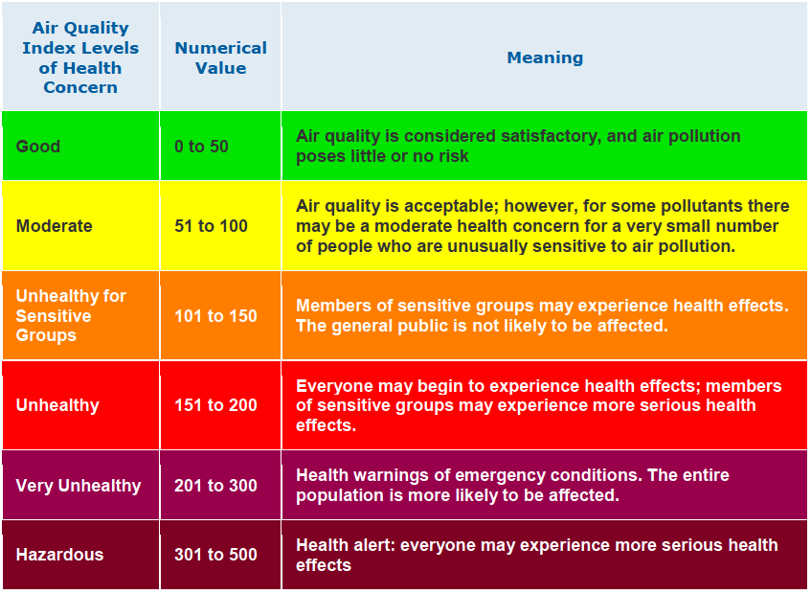
Figure 2. Air Quality Index developed by the United States Environmental Protection Agency (US EPA).

The research team will utilize the following platforms for disseminating data: technical reports and infographics (available as downloadable PDFs), a unique data portal website providing near real-time access to air pollution data, social media (including project-specific Facebook, Instagram, and Twitter pages). This will encourage access on both computers and mobile devices. In addition, we plan to share information through email and text alerts with local community centers, libraries, and places of worship as local dissemination venues.

Deliverables: Research team will share data from the air monitoring network with the Mayor of Cheverly and local stakeholder groups through community reports, technical reports, social media pages, newsletters, and quarterly reports. The team will also hold monthly meetings with the Mayor and the residents as part of report back sessions and discuss challenges and concerns associated with the project in the first year of operating the hyperlocal monitoring network and quarterly meetings from years 2-5+. The team will also establish and manage an online helpline platform (e.g., a project contact e-mail account) where residents and interested parties can direct questions, comments, and other feedback regarding data.

Outcome start date: June 1, 2019
Outcome end date: May 31, 2024

- ADMINISTRATION. Dr. Wilson will act as the principal investigator and project manager for the air quality monitoring network. An advisory board for this project will be developed with stakeholders from the communities of concern including the Mayor’s Office. The advisory board will provide feedback during all stages of the monitoring project. The board will meet monthly via teleconference to discuss research progress, results, and share in decision-making.

- TIMELINE
We anticipate that the project will begin in February 2019. Long-term monitoring will continue at these sites for the next 1-5 years.

 | February 2019 | March 2019 | April 2019 | May 2019 | June 2019 - May 31, 2024
Objective 1 | CAB, Air Monitoring Network Plan
Objective 2 |  | Deploy Sensors
Objective 3 |  |  |  |  | Collect and Manage Data
Objective 4 |  |  |  |  | Interpret and Share Data

- BUDGET AND JUSTIFICATION
Item | Description | Year 1 Cost | Years 2-5
Monitoring Devices
Purple Air Sensors (PA-II) | 25 units at $230/unit | $ 5750
Aeroqual AQY1 Sensors (AQY1) | 5 units at $3000 | $15000
Wi-Fi Connectivity for PA-IIs
T-mobile or Verizon hotspot with 2G Data Plan | 25 units at $20/month/year (Only needed if monitoring location does not already have Wi-Fi) | $6,000 | $24,000
Personnel Costs | Costs of weekly checks on the instruments, instrument maintenance, data download, and data interpretation. Estimated number of hours/week in year 1 (25 hours/week at $20/hour); Estimated hours/week/year in years in years 2-5 (15 hours/week at $20/hour); Estimated costs for year 1 ($26,000); Estimated costs/year for years 2-5 ($15,600/year) | $13,000 | $30,000
Website- stakeholders can visit this site to see daily, weekly, and monthly readings in the form of maps, tables, and graphs | Initial Development of Website- Year 1, website maintenance years 2-5 ($1500/year) | $5,000 | $6,000
Total |  | $44,750 | $60,000

- TABLE(S)

Table 1. Environmental and Demographic Indicators for Cheverly, Maryland (EJScreen)
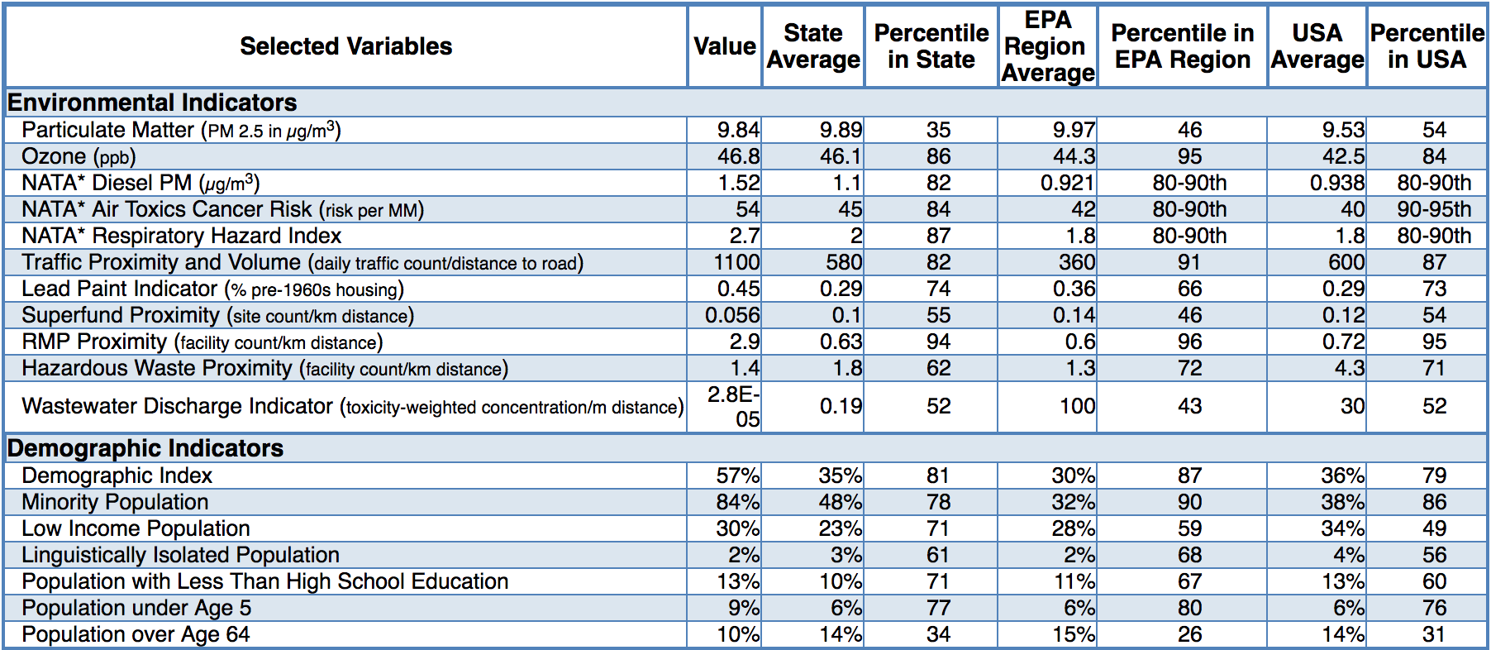

Table 2. Environmental and Demographic Indicators around Smith & Sons Metal Recycling Cheverly, Maryland (EJScreen)
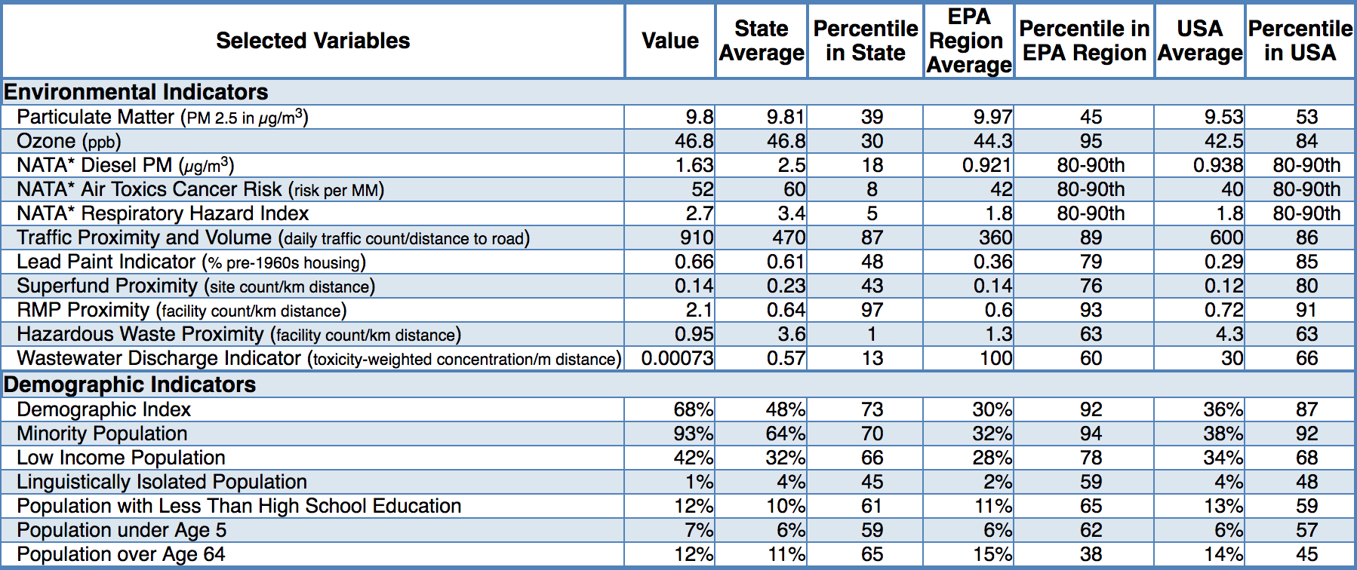

Table 3. Environmental and Demographic Indicators around World Recycling Co., Cheverly, Maryland (EJScreen)
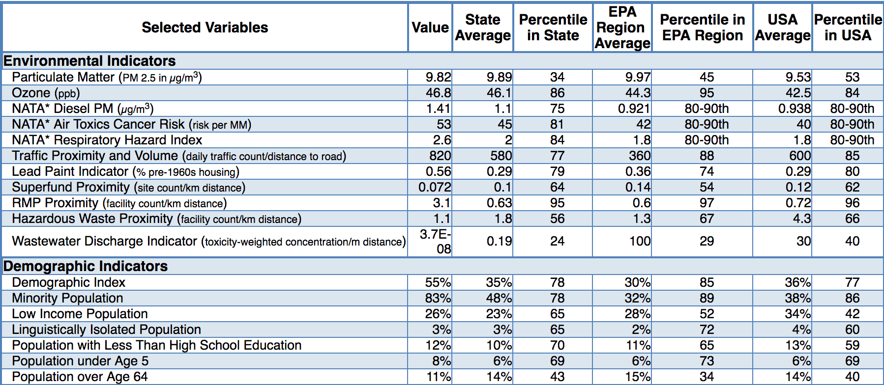

Table 4. Environmental and Demographic Indicators for Capitol Heights, Maryland (EJScreen)
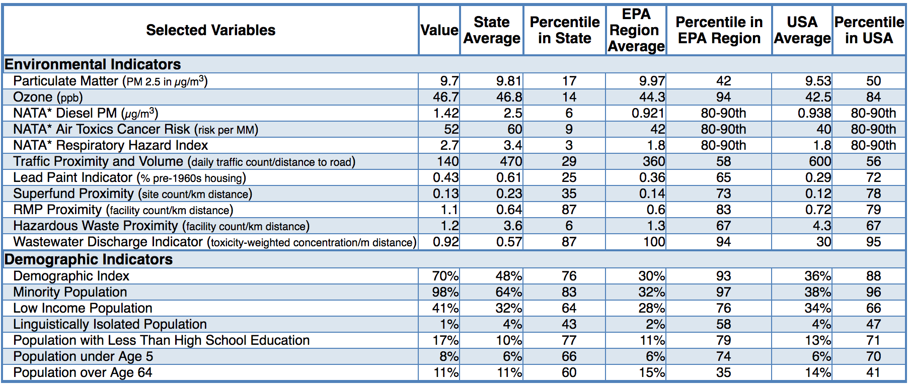

Table 5. Environmental and Demographic Indicators for Lafarge North America Concrete Batch Plant, Sheriff Road, Maryland (EJScreen)
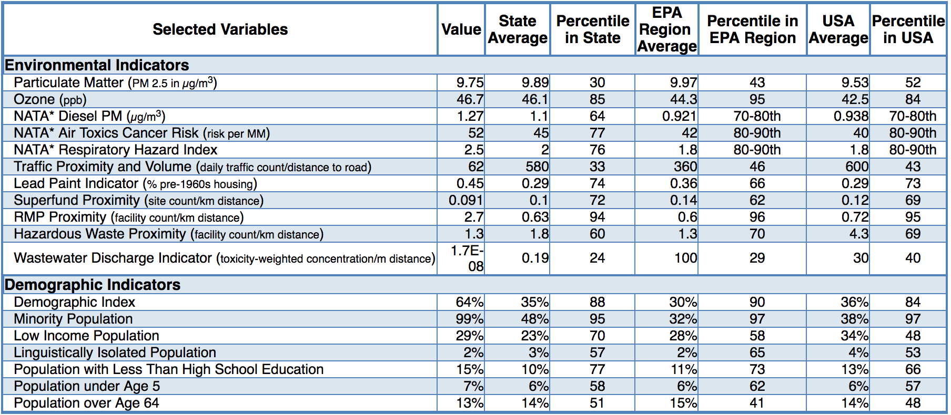

Table 6. List of Pollution Sources and Potential Air Quality Monitoring Locations
Site Name | Site Address | Sensor Type
LaFarge North America Concrete Batch Plant* | 5850 Sheriff Rd, Capitol Heights, MD 20743 | Pollution Source
Joseph Smith & Sons Inc Scrap Metal Recycling | 4501 S Street, Capitol Heights, MD 20743 | Pollution Source
World Recycling Co | 5600 Columbia Park Rd, Cheverly, MD 20785 | Pollution Source
Cedar Heights Community Center | 1200 Glen Willow Drive, Capitol Heights, MD 20743 | Aeroqual AQY1
Community Temple Church | 6207 State Street, Cheverly, MD 20785 | Aeroqual AQY1
Hosanna Worship Church Christ | 1723 Kenilworth Avenue, Capitol Heights, MD 20743 | Aeroqual AQY1
Spirit of Peace Baptist Church | 4311 R Street, Capitol Heights, MD 20743 | Aeroqual AQY1
Boyd Park | 1801 64th Avenue, Hyattsville, MD, 20785 | Aeroqual AQY1
Gast Park | Parkway Street, Cheverly, MD 20785 | Purple Air PA-II
Cheverly East Neighborhood Park | Cheverly, MD, 20785 | Purple Air PA-II
Woodworth Park | Cheverly Park Drive, MD, 20785 | Purple Air PA-II
Gray Elementary School | 4949 Addison Rd, Capitol Heights, MD 20743 | Purple Air PA-II
Addison Chapel Apartments | 1525 Elkwood Ln, Capitol Heights, MD 20743 | Purple Air PA-II
Chapel Oaks County Fire Station | 5544 Sheriff Rd, Capitol Heights, MD 20743 | Purple Air PA-II
Fairmount Heights Branch Library | 5904 Kolb St, Capitol Heights, MD, 20743 | Purple Air PA-II
Cheverly Nature Park | Cheverly, MD 20743 | Purple Air PA-II
Fairmount Heights Park | 5395 Sheriff Rd, Fairmount Heights, MD 20743 | Purple Air PA-II
Public Storage | 5556 Tuxedo Road, Hyattsville, MD 20781 | Purple Air PA-II
Cheverly Police Department/Community Center | 6401 Forest Rd, Cheverly, MD 20785 | Purple Air PA-II
Gladys Noon Spellman Elementary School | 3324 64th Ave, Cheverly, MD 20785 | Purple Air PA-II
Cheverly Euclid Street Neighborhood Park | 5610 Euclid St, Cheverly, MD 20785 | Purple Air PA-II
Hoyer Early Childhood Center | 2300 Belleview Ave, Cheverly, MD, 20785 | Purple Air PA-II
UM Prince George's Hospital Center | 3001 Hospital Dr, Hyattsville, MD 20785 | Purple Air PA-II
Jesse Warr Recreation Center | 5200 North Englewood Drive, Hyattsville, MD 20785 | Purple Air PA-II
Washington Baptist Church | 1409 Ivywood Ave, Hyattsville, MD 20785 | Purple Air PA-II
Magruder Spring Historic Landmark | 2202 Cheverly Avenue, Cheverly, MD 20785 | Purple Air PA-II
Victory Temple of Deliverance | 909 Nyanga Avenue, Capitol Heights, MD 20743 | Purple Air PA-II
Booker T Homes Neighborhood Park | 1250 Booker Terrace, Landover, MD 20785 | Purple Air PA-II
St Matthew CME Church | 923 Cedar Heights Drive, Capitol Heights, MD 20743 | Purple Air PA-II
Cathedral of Christ | 5354 Sheriff Road, Capitol Heights, MD 20743 | Purple Air PA-II
Rising Star Holy Temple | 5312 Sheriff Road, Capitol Heights, MD 20743 | Purple Air PA-II
Fairmount Heights High School | 6501 Columbia Park Road, Hyattsville, MD 20785 | Purple Air PA-II
Jesse Warr Recreation Center | 5200 North Englewood Drive, Hyattsville, MD 20785 | Purple Air PA-II

References
Afroz, R., Hassan, M. N., & Ibrahim, N. A. (2003). Review of air pollution and health impacts in Malaysia. Environmental Research, 92(2), 71–77. https://doi.org/10.1016/S0013-9351(02)00059-2
Alvarez-Vázquez, L. J., García-Chan, N., Martínez, A., & Vázquez-Méndez, M. E. (2017). Numerical simulation of air pollution due to traffic flow in urban networks. Journal of Computational and Applied Mathematics, 326(Supplement C), 44–61. https://doi.org/10.1016/j.cam.2017.05.017
Arias-Ortiz, N. E., Icaza-Noguera, G., & Ruiz-Rudolph, P. (2017). Thyroid cancer incidence in women and proximity to industrial air pollution sources: A spatial analysis in a middle size city in Colombia. Atmospheric Pollution Research. https://doi.org/10.1016/j.apr.2017.11.003
Bergdahl, I. A., Torén, K., Eriksson, K., Hedlund, U., Nilsson, T., Flodin, R., & Järvholm, B. (2004). Increased mortality in COPD among construction workers exposed to inorganic dust. European Respiratory Journal, 23(3), 402–406. https://doi.org/10.1183/09031936.04.00034304
Bertoldi, M., Borgini, A., Tittarelli, A., Fattore, E., Cau, A., Fanelli, R., & Crosignani, P. (2012). Health effects for the population living near a cement plant: An epidemiological assessment. Environment International, 41, 1–7. https://doi.org/10.1016/j.envint.2011.12.005
Colvile, R. N., Hutchinson, E. J., Mindell, J. S., & Warren, R. F. (2001). The transport sector as a source of air pollution. Atmospheric Environment, 35(9), 1537–1565. https://doi.org/10.1016/S1352-2310(00)00551-3
de Buy Wenniger, L. J. M., Culver, E. L., & Beuers, U. (2014). Exposure to occupational antigens might predispose to IgG4-related disease. Hepatology, 60(4), 1453–1454. https://doi.org/10.1002/hep.26999
Fernández-Navarro, P., García-Pérez, J., Ramis, R., Boldo, E., & López-Abente, G. (2017). Industrial pollution and cancer in Spain: An important public health issue. Environmental Research, 159(Supplement C), 555–563. https://doi.org/10.1016/j.envres.2017.08.049
Gupta, R. K., Majumdar, D., Trivedi, J. V., & Bhanarkar, A. D. (2012). Particulate matter and elemental emissions from a cement kiln. Fuel Processing Technology, 104(Supplement C), 343–351. https://doi.org/10.1016/j.fuproc.2012.06.007
Heederik, D., Kromhout, H., Burema, J., Biersteker, K., & Kromhout, D. (1990). Occupational Exposure and 25-Year Incidence Rate of Non-Specific Lung Disease: The Zutphen Study. International Journal of Epidemiology, 19(4), 945–952. https://doi.org/10.1093/ije/19.4.945
Hirsch, T., Weiland, S. K., von Mutius, E., Safeca, A. F., Gräfe, H., Csaplovics, E., … Leupold, W. (1999). Inner city air pollution and respiratory health and atopy in children. The European Respiratory Journal, 14(3), 669–677.
Hnizdo, E., Sullivan, P. A., Bang, K. M., & Wagner, G. (2002). Association between Chronic Obstructive Pulmonary Disease and Employment by Industry and Occupation in the US Population: A Study of Data from the Third National Health and Nutrition Examination Survey. American Journal of Epidemiology, 156(8), 738–746. https://doi.org/10.1093/aje/kwf105
Huntzinger, D. N., & Eatmon, T. D. (2009). A life-cycle assessment of Portland cement manufacturing: comparing the traditional process with alternative technologies. Journal of Cleaner Production, 17(7), 668–675. https://doi.org/10.1016/j.jclepro.2008.04.007
Kim, K.-H., Kabir, E., & Kabir, S. (2015, January). A review on the human health impact of airborne particulate matter - ScienceDirect. Retrieved April 6, 2018, from https://www-sciencedirect-com.proxy-um.researchport.umd.edu/science/article/pii/S0160412014002992
Mecklenburg County, North Carolina. (2014). Stationary Sources. Retrieved January 27, 2018, from https://www.mecknc.gov/LUESA/AirQuality/EducationandOutreach/Documents/2014StationarySources.pdf
Mehraj, S. S., Bhat, G. A., & Balkhi, H. M. (2013). CEMENT FACTORIES AND HUMAN HEALTH -. International Journal of Current Research and Review, 5(18), 47–53.
Mustafic, H., Jabre, P., Caussin, C., Murad, M. H., Escolano, S., Tafflet, M., … Jouven, X. (2012). Main air pollutants and myocardial infarction: a systematic review and meta-analysis. JAMA, 307(7), 713–721. https://doi.org/10.1001/jama.2012.126
NJDEP. (2018, January 16). WHAT ARE POINT, AREA, AND MOBILE SOURCES? Retrieved January 30, 2018, from http://www.nj.gov/dep/airtoxics/sourceso99.htm
Nkhama, E., Ndhlovu, M., Dvonch, J. T., Siziya, S., & Voyi, K. (2015). Prevalence and Determinants of Mucous Membrane Irritations in a Community Near a Cement Factory in Zambia: A Cross Sectional Study. International Journal of Environmental Research and Public Health, 12(1), 871–887. https://doi.org/10.3390/ijerph120100871
O’Connor, G. T., Neas, L., Vaughn, B., Kattan, M., Mitchell, H., Crain, E. F., … Lippmann, M. (2008). Acute respiratory health effects of air pollution on children with asthma in US inner cities. Journal of Allergy and Clinical Immunology, 121(5), 1133-1139.e1. https://doi.org/10.1016/j.jaci.2008.02.020
Office of Air Quality Planning and Standards, Office of Air and Radiation, & US EPA. (2006, June). Emission Factor Documentation for AP-42 Section 11.12 Concrete Batching. Retrieved January 16, 2018, from https://www3.epa.gov/ttnchie1/ap42/ch11/bgdocs/b11s12.pdf
Schuhmacher, M., Domingo, J. L., & Garreta, J. (2004). Pollutants emitted by a cement plant: health risks for the population living in the neighborhood. Environmental Research, 95(2), 198–206. https://doi.org/10.1016/j.envres.2003.08.011
Shah, A. S., Langrish, J. P., Nair, H., McAllister, D. A., Hunter, A. L., Donaldson, K., … Mills, N. L. (2013). Global association of air pollution and heart failure: a systematic review and meta-analysis. The Lancet, 382(9897), 1039–1048. https://doi.org/10.1016/S0140-6736(13)60898-3
TCEQ. (2018, January 11). Sources of Air Emissions. Retrieved January 30, 2018, from https://www.tceq.texas.gov/airquality/areasource/Sources_of_Air_Pollution.html
US EPA, O. (2015, May 6). Stationary Sources of Air Pollution [Collections and Lists]. Retrieved January 14, 2018, from https://www.epa.gov/stationary-sources-air-pollution
US EPA, O. (2016, June 8). How Mobile Source Pollution Affects Your Health [Overviews and Factsheets]. Retrieved January 14, 2018, from https://www.epa.gov/mobile-source-pollution/how-mobile-source-pollution-affects-your-health
US EPA, O. (2018a, February 5). Instruction Guide and Macro Analysis Tool: Evaluating Low-Cost Air Sensors by Collocation with Federal Reference Monitors. Retrieved from https://www.epa.gov/air-research/instruction-guide-and-macro-analysis-tool-evaluating-low-cost-air-sensors-collocation
US EPA, O. (2018b, September 26). Air Sensor Toolbox for Citizen Scientists, Researchers and
Developers. Retrieved from https://www.epa.gov/air-sensor-toolbox.
Wjst, M., Reitmeir, P., Dold, S., Wulff, A., Nicolai, T., von Loeffelholz-Colberg, E. F., & von Mutius, E. (1993). Road traffic and adverse effects on respiratory health in children. BMJ : British Medical Journal, 307(6904), 596–600.

